Project Design Phase-II

Data Flow Diagram & User Stories

Date | 17 October 2022
Team ID | PNT2022TMID08747
Project Name | Gas Leakage Monitoring and Alerting  System
Maximum Marks | 4 Marks

DATA FLOW DIAGRAM:

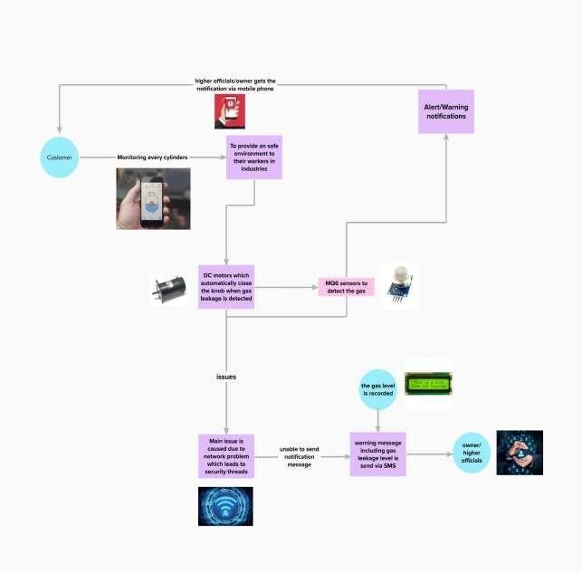

User Stories
Use the below template to list all the user stories for the product.
User Type | Functional Requirement  (Epic) | User Story  Number | User Story / Task | Acceptance criteria | Priority | Release
Customer(family | Registration | USN-1 | As a user ,I can | I can access my account / | High | Sprint-1
member/industry | Registration | USN-1 | register for the | dashboard | High | Sprint-1
owner) | Registration | USN-1 | device in the owners |  | High | Sprint-1
 | Registration | USN-1 | mobile application by |  | High | Sprint-1
 | Registration | USN-1 | entering my email |  | High | Sprint-1
 | Registration | USN-1 | and password |  | High | Sprint-1
Customer(higher | confirmation | USN-2 | As a user I will | I can receive confirmation | High | Sprint-1
authority) | confirmation | USN-2 | receive confirmation | email & click confirm | High | Sprint-1
 | confirmation | USN-2 | message via email |  | High | Sprint-1
 | confirmation | USN-2 | and once I received |  | High | Sprint-1
 | confirmation | USN-2 | I can install the |  | High | Sprint-1
 | confirmation | USN-2 | device in the |  | High | Sprint-1
 | confirmation | USN-2 | owners place |  | High | Sprint-1
Customer  (fire service 101) | Safety measure register | USN-3 | As a register I can register the  application in | I can register & access the dashboard with Facebook Login | Low | Sprint-2
Customer  (fire service 101) | Safety measure register | USN-3 | owner/family | I can register & access the dashboard with Facebook Login | Low | Sprint-2
Customer  (fire service 101) | Safety measure register | USN-3 | members mobile | I can register & access the dashboard with Facebook Login | Low | Sprint-2
Customer  (fire service 101) | Safety measure register | USN-3 | phone | I can register & access the dashboard with Facebook Login | Low | Sprint-2
Customer (mobile user) | Mobile application | USN-4 | As a user I can register by mobile application | I can register for gas detection device with owners mobile number and the alert message  will be send by SMS | Medium | Sprint-1
Customer | Login | USN-5 | As a user I can log | Mail address and passwords | High | Sprint-1
(credential) | Login | USN-5 | into the device by | are default | High | Sprint-1
 | Login | USN-5 | entering email & |  | High | Sprint-1
 | Login | USN-5 | password in the |  | High | Sprint-1
 | Login | USN-5 | owner’s mobile |  | High | Sprint-1
 | Login | USN-5 | application |  | High | Sprint-1
Customer | Notification | USN-7 | As a user when | Alert message is sent to | High | Sprint-1
(Web user) | Notification | USN-7 | there is a critical situation regarding  gas explosion the alert notification will | owners mobile as an SMS | High | Sprint-1
 | Notification | USN-7 | be received through |  | High | Sprint-1
 | Notification | USN-7 | GSM module |  | High | Sprint-1
Customer care Executive | Network Connectivity | USN-8 | When there is a gas leakage is detected in the surrounding | Sensor detect the leakage and notifies the owner via message | High | Sprint-1
User Type | Functional  Requirement (Epic) | User  Story Number | User Story / Task | Acceptance criteria | Priority | Release
Administration | Accessing | USN-9 | When there is an  issue in accessing the device | Admin/Device operator’s advice should be undertaken | High | Sprint-1

